# CLDV POE PART 1

# ST 10441724

# AADI VINAY MOHANLAL

**Web App URL:** st10441724-g4bjhkbph2fjaeat.southafricanorth-01.azurewebsites.net

**GitHub Repository Link:** https://github.com/IIEWFL/cldv6211-part-1-ST10441724-Aadi-Mohanlal.git

**D. Cloud Computing Basics**

**1. Differences Between Deploying an Application in the Cloud vs. On-Premises**

|  |  |  |
| --- | --- | --- |
| Aspect | On-Premises | Cloud Deployment |
| Security | |  | | --- | |  |  |  | | --- | | You have full control over security infrastructure, but this means **you are fully responsible** for physical and cyber protection. |   Example: You need to manage firewalls, intrusion detection, and software patching manually. | Security is managed by the cloud provider up to a certain level. Cloud services often offer built-in identity access management, encryption, and compliance tools.  Example: AWS offers services like IAM, GuardDuty, and Shield to help monitor and protect applications. |
| Deployment Speed | Slower, as you need to provision hardware, configure networks, and set up software environments.  *Example:* Buying a new server might take weeks. | Faster due to on-demand infrastructure and automated tools. You can deploy in **minutes using templates or containers**.  *Example:* Using Azure DevOps pipelines, you can auto-deploy to production after code is pushed. |
| Resource Management | Static resources – upgrading requires manual scaling (e.g., buying more servers). Risk of **underutilization or over-provisioning**. | Dynamic and elastic – resources can scale automatically based on demand. You **only pay for what you use**.  *Example:* An e-commerce app can auto-scale on AWS EC2 during Black Friday. |

**2. Key Differences: IaaS vs. PaaS vs. SaaS**

|  |  |  |  |
| --- | --- | --- | --- |
| Service Model | What it provides? | Example | User Responsibility? |
| **IaaS** (Infrastructure as a Service) | Virtual machines, storage, and networks. | Amazon EC2, Microsoft Azure VMs | You manage OS, runtime, and the app. |
| **PaaS** (Platform as a Service) | A ready-made platform to build and deploy apps without managing the infrastructure. | Google App Engine, Azure App Service | You manage the app and data. The provider handles OS, patching, and scaling. |
| **SaaS** (Software as a Service) | Fully functional software delivered via the internet. | Gmail, Microsoft 365, Dropbox | You just use the app. The provider handles everything. |

**Why EventEase Would Benefit from PaaS**

**EventEase** would benefit most from **PaaS**, because:

* **Faster Development**: Developers can focus on coding and app logic rather than worrying about setting up servers or databases.
  + ▶ *Example:* With Azure App Service, they can deploy code directly from GitHub, while the platform handles scaling and updates.
* **Built-in Tools**: PaaS often includes tools for **monitoring, security, authentication**, and CI/CD.
  + ▶ *Example:* Google Firebase (a PaaS) gives real-time database, analytics, and hosting in one bundle.
* **Cost Efficiency**: EventEase avoids costs related to infrastructure maintenance, which is ideal for a startup or growing business.

**Comparison Example:**

|  |  |  |  |
| --- | --- | --- | --- |
| **Feature** | **IaaS** | **PaaS** | **SaaS** |
| Control | Full | Moderate | Low |
| Maintenance Effort | High | Medium | None |
| Ideal For | System Admins | App Developers | End Users |
| EventEase Use Case | Too Complex | Best Fit | Too Limited |

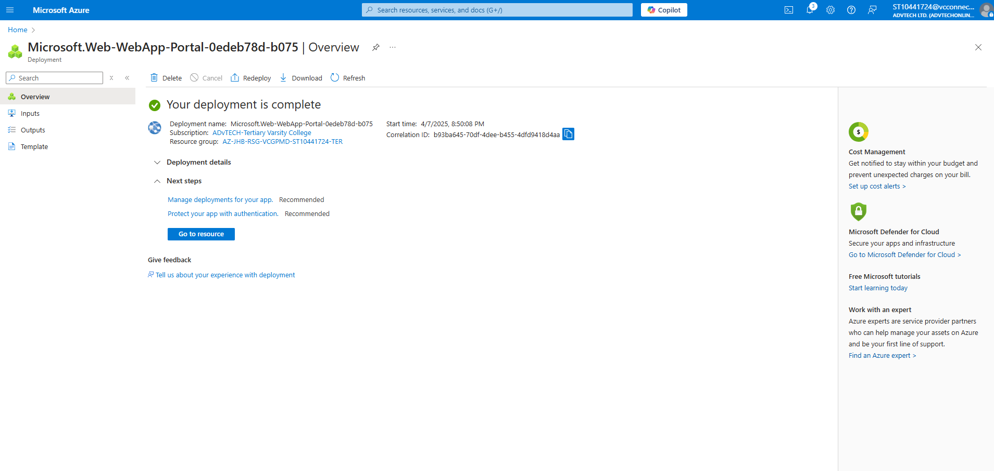

**References**

* PaaS vs. IaaS vs. SaaS vs. CaaS: How are they different? Google Cloud [Accessed on April 6, 2025] Available on: <https://cloud.google.com/learn/paas-vs-iaas-vs-saas>
* What are Iaas, Paas and Saas? IBM [Accessed on April 6, 2025] Available on: <https://www.ibm.com/think/topics/iaas-paas-saas>
* What is a cloud server? TechTarget [Published on November 2024. Accessed on April 6, 2025] Available on: <https://www.techtarget.com/searchcloudcomputing/definition/cloud-server>

**Videos used for the creation of the web app on visual studio:** https://www.youtube.com/playlist?list=PL480DYS-b_kevhFsiTpPIB2RzhKPig4iK